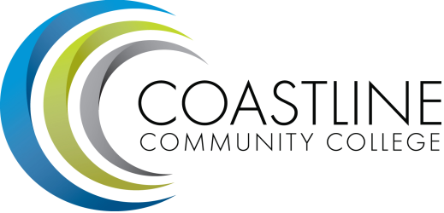
Accreditation Steering Agenda
10/19/17
1:00 pm - 3:00 pm
College Center 4th Floor Conference Room

Committee Mandate: To guide the College through the self-evaluation process for the purpose of continuous self-improvement as evidenced by the Institutional Self-Evaluation Report.

**Note: the 10/5/17 meeting was cancelled. This agenda is similar to the one planned for 10/5/17.

- CALL TO ORDER
  - Roll Call
  - Welcome
  - Adoption of Agenda
  - Minutes from 9/21

- SPECIAL REPORTS & UPDATES
2.1 October 1 Deadline (D. Pittaway)

- ACTION ITEMS

- STANDING REPORTS
  - Standard I (chairs)
  - Standard II (chairs)
  - Standard III (chairs)
  - Standard IV (chairs)

- DISCUSSION ITEMS
  - November 1 Deadline (D. Pittaway)
  - Evidence Naming Convention (D. Pittaway / M. Yanalunas)
  - Accreditation Awareness Campaign(D. Pittaway)

- ANNOUNCEMENTS (1-2 minutes per)

- ADJOURNMENT

- Next meeting will occur Thursday, November 2nd, 1:00-3:00 pm, 4th floor conference room @College Center. Meeting schedule is 1st and 3rd Thursdays at 1:00 pm during fall and spring terms for 2017-2018.

- Our goal for fall 2017 will be to develop a complete first draft of the self-study report due this December before we break for the holiday. The final, constituency-approved report is due to ACCJC December 2018.

- Google Accreditation Writing Space

